Congress shall make no law respecting an establishment of religion or prohibiting the free exercise thereof; or abridging the freedom of speech, or of the press; or the right of the people peaceably to assemble,
and to petition the government for a redress of grievances.

The First Amendment is:

- Part of the Bill of Rights (the first 10 amendments to the U.S. Constitution).
- More than 225 years old. (It was ratified — made part of the Constitution — in 1791.)
- Our nation’s blueprint for freedom of expression and religious liberty for all.
- A statement that limits the government’s ability to restrict the rights of individuals.

Religion: The First Amendment protects the right to freely exercise any religious faith, or no
religious faith. You can believe whatever you want to believe and practice your religion openly without fear of persecution.

The First Amendment also prohibits the government from establishing an official religion. That is why, for example, public school teachers are not allowed to lead their students in prayer. The Supreme Court has ruled that public school teachers leading prayers could make it appear that the government favors one religion over another.

These protections are often referred to as the Establishment Clause of the First Amendment.

Speech: The First Amendment protects the right to express your beliefs and ideas through words — written or spoken — and through symbolic speech. Symbolic speech uses images, actions or other non-verbal methods to communicate an idea. The First Amendment protects the right to express even unpopular or controversial ideas.

Press: The First Amendment protects the right to publish information in print, on television or on the Internet. For the most part, the news media are free to publish any information or opinion they desire with interference or censorship by the government.

Assembly: The First Amendment protects individuals’ freedom to gather together peacefully in groups. Working together, groups can have a much greater impact than an individual working alone.

Petition: The First Amendment protects the right to ask government at any level — local, state or federal — to change a policy, right a wrong or correct a problem. Individuals can petition the government using any legal, nonviolent methods of communicating their concerns, from traditional signed petitions to phone calls to Twitter.

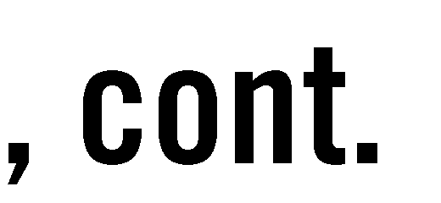

If we didn’t have the First Amendment …
- Religious minorities could be persecuted.
- The government could establish a national religion.
- Individuals could be punished for expressing unpopular ideas.
- Protesters could be silenced.
- The press could be banned from criticizing government.
- Citizens could be prevented from gathering together to work for or against social change. Sources for more information on the First Amendment:

First Amendment Schools: The five freedoms FAQs and key court cases
- Student- and school-centered overview of the five freedoms
- http://www.firstamendmentschools.org/freedoms/speech.aspx

SCOTUSblog: First Amendment cases
- In-depth summaries and analyses of recent and current First Amendment cases before the Supreme Court
- http://www.scotusblog.com/?s=First+Amendment&searchsubmit=Blog

Oyez: First Amendment cases
- Summaries and decisions from historical and current First Amendment cases before the Supreme Court
- http://www.oyez.org/issues/first_amendment

Date:

How is the First Amendment important in your life? Use the boxes below to brainstorm ways in which you use or have already used each freedom and ways in which you could use the freedom in the future. Try to come up with at least one idea for each box.

Freedom | How I use/have used this freedom: | How I could use this freedom in the future:
Religion
Speech
Press
Assembly
Petition

Visit the First Amendment Gallery (Level 4) to answer the following questions.

Pick one of the five freedoms (religion, speech, press, petition, assembly) to investigate.

Chosen freedom:

Explain the meaning of the freedom and its origins:

Identify a pivotal Supreme Court case for the freedom and describe its impact:

Case:

Impact:

Identify two other examples of the freedom being used. Then explain if the First Amendment supports each example.

Head to the Bart Simpson wall. Choose an example of a student using a First Amendment freedom and describe the event.

Compare the student example with an example of your chosen freedom from the main display. How were the actions and consequences similar and different?

How did the school respond to the student’s actions? In your opinion, were the student’s First Amendment rights violated? Explain your answer and use evidence from the display to support your argument.

Should the First Amendment apply equally to students and the general public? Students attend school to get an education. What if using the five freedoms interfered with learning? Does that change your answer? Why or why not?

