Below are some terms that have to do with photojournalism and making ethical choices as a journalist. Select three terms to research. Find out what these terms mean in relation to photojournalism. Create your own definitions for the three terms. Then find examples of these terms (photographs that illustrate the term or the different standards and codes) in newspapers, magazines or on Internet news sites.

- Angle (low, middle, high)

- Candid

- Captions/cutlines

- Codes of ethics

- Composition

- Credibility

- Crop

- Concept illustration

- Ethics
- False light

- Graphic

- Journalistic standards

- Offensive material

- Photo illustration

- Photo manipulation

- Posed/staged

- Rule of thirds

- Sensationalism

Pulitzer Prize Photographs Gallery Guide

Visit the Pulitzer Prize Photographs Gallery on Level 1. Choose one image you are drawn to or one you are repelled by — something to which you have an immediate reaction.

Part I – Answer the Reporter’s Questions (Who, What, When, Where, Why and How)

What does this image show? A person, a thing, a place? Describe:

Who took the photograph?

Where was this image taken?

__________________________________________________________________________

When was this image taken?

Why do you think this image was taken? Does it try to convey a message or idea? Use details from the photograph to support your answer.

__________________________________________________________________________

__________________________________________________________________________

__________________________________________________________________________

__________________________________________________________________________

How does this image impact you emotionally? Explain:

__________________________________________________________________________

__________________________________________________________________________

Part II – Investigate and dig deeper.
Describe the larger world event, story or social issue referenced by the photograph. Use the summary of the photograph to support your answer.

___________________________________________________________________________

___________________________________________________________________________

___________________________________________________________________________

What specific information does the photograph add to the description?

___________________________________________________________________________

___________________________________________________________________________

___________________________________________________________________________

How does the photograph improve your understanding of the event, story or social issue?

___________________________________________________________________________

___________________________________________________________________________

___________________________________________________________________________

Describe two missing perspectives and facts that could help you better understand the event. What else would you like to know?

Perspective | Facts

Name two specific sources where you could find these missing perspectives and facts.

1: _________________________________________________________________________

___________________________________________________________________________

2: _________________________________________________________________________

___________________________________________________________________________

Preamble: The National Press Photographers Association, a professional society that promotes the highest standards in visual journalism, acknowledges concern for every person's need both to be fully informed about public events and to be recognized as part of the world in which we live.

Visual journalists operate as trustees of the public. Our primary role is to report visually on the significant events and varied viewpoints in our common world. Our primary goal is the faithful and comprehensive depiction of the subject at hand. As visual journalists, we have the responsibility to document society and to preserve its history through images.

Photographic and video images can reveal great truths, expose wrongdoing and neglect, inspire hope and understanding and connect people around the globe through the language of visual understanding. Photographs can also cause great harm if they are callously intrusive or are manipulated.

This code is intended to promote the highest quality in all forms of visual journalism and to strengthen public confidence in the profession. It is also meant to serve as an educational tool both for those who practice and for those who appreciate photojournalism. To that end, The National Press Photographers Association sets forth the following.

CODE OF ETHICS

Be accurate and comprehensive in the representation of subjects.
- Resist being manipulated by staged photo opportunities.
- Be complete and provide context when photographing or recording subjects. Avoid stereotyping individuals and groups. Recognize and work to avoid presenting one’s own biases in the work.
- Treat all subjects with respect and dignity. Give special consideration to vulnerable subjects and compassion to victims of crime or tragedy. Intrude on private moments of grief only when the public has an overriding and justifiable need to see.
- While photographing subjects do not intentionally contribute to, alter, or seek to alter or influence events.
- Editing should maintain the integrity of the photographic images’ content and context. Do not manipulate images or add or alter sound in any way that can mislead viewers or misrepresent subjects.
- Do not pay sources or subjects or reward them materially for information or participation.
- Do not accept gifts, favors, or compensation from those who might seek to influence coverage.
- Do not intentionally sabotage the efforts of other journalists.

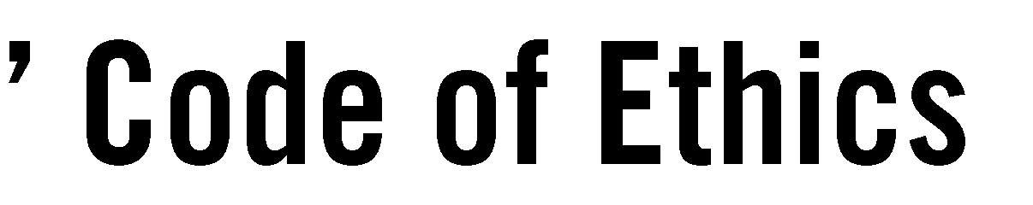
Read the National Press Photographers Association Code of Ethics to get an understanding of best practices in the profession. Then find five examples of photographs that do and do not meet the ethical standards. Look for examples in newspapers, magazines and on online news sites. Tell why the photo does or does not uphold the principle. Be sure to attach the examples to the writing.

PHOTO 1
Photo description:

Relevant ethical standard: Summary of whether the photo meets the standard or not:

PHOTO 2
Photo description:

Relevant ethical standard: Summary of whether the photo meets the standard or not:

PHOTO 3
Photo description:

Relevant ethical standard: Summary of whether the photo meets the standard or not:

PHOTO 4
Photo description: Relevant ethical standard: Summary of whether the photo meets the standard or not:

PHOTO 5
Photo description: Relevant ethical standard: Summary of whether the photo meets the standard or not:

