Free Expression & Censorship: Banned Books

OBJECTIVE: In this activity, students will learn about the First Amendment’s guarantee of freedom of expression and about censorship by looking at the examples of banned children’s books. Then they will get a taste of the effect censorship has on free expression by creating two murals — one created freely and one censored.

GRADE LEVEL: Elementary school

TIME: 45 minutes
15 minutes to complete/discuss matching game 30 minutes to complete/discuss mural activity

MATERIALS: Copies of “Why Was It Banned?” matching game activity sheet (download); large pieces of paper/cardboard for murals; markers, paint or crayons; copies of mural rules (download)

PREPARE
- Print copies of the matching game activity sheet, one per group.
- Print and display copies of “Free! Mural Rules” and “Censored! Mural Rules.”

DO
- Tell your students that they’re going to learn about freedom of expression and censorship, using the examples of banned children’s books.
- Have students work in small groups to complete the “Why Was It Banned?” matching game activity sheet. Go over the answer key with them and discuss what they found. Ask:
  - Have you read any of the books on this list? Did you like them? Were you surprised that they’d been banned?
  - Why do you think some people try to ban books they don’t like?
- Tell your students that they are going to do an activity to show how censorship affects
our ability to freely express ourselves. They are going to create two murals about attending school. On one of them, they are free to use any colors they want and draw pictures of any parts of the school day that they’d like to show. On the other mural, they can only use black, brown or gray colors to only draw pictures that show children attentive and serious. Tell them you will be “the censor,” and if at any time you don’t like what they’re drawing, you have the right to use a black marker/crayon/paint and cover it up. Put up copies of the “Free! Mural Rules” and "Censored! Mural Rules" so that everyone can see them while they work. Divide the group in half and assign half to the free mural and half to the censored mural. (If you have a large class, you may want multiple “free” and “censored” tables.) Halfway through, have the students switch stations. Throughout the time that they are working on the murals, remind them of the rules and use your power as the censor.

DISCUSS
After 15-20 minutes, stop and discuss the final products and the experience of creating the two murals.

  - Which mural did you enjoy working on more? Why?
  - Which mural do you like better? Why?
  - Which mural does a better job of showing what your school/camp is really like? Why?
  - What did it feel like to have a censor watching you work and controlling what you could do?
  - Do you think it’s important to protect freedom of expression? Why?

Why Was It Banned? — ANSWER KEY

“Where the Wild Things Are”

by Maurice Sendak
A little boy who’s angry at his parents is whisked away to a magical land, where he becomes king of all the wild beasts.
Shows wild behavior and supernatural events
“A Light in the Attic”
by Shel Silverstein
Goofy poems for children, including “How Not to Have to Dry the Dishes” and “Little Abigail and the Beautiful Pony.”
Encourages children to break dishes instead of drying them properly
“The Lion, the Witch and the Wardrobe”
by C.S. Lewis
Three children find a secret world and fight to free it from the evil witch who’s made herself queen of the land.
Encourages children to become witches

The Harry Potter book series
by J.K. Rowling
A young boy discovers he’s actually a wizard and encounters many adventures when he goes to a school for young wizards.
Includes violence and mystical powers

The Captain Underpants book series
by Dav Pilkey
The adventures of a scantily-clad superhero created by two fourth-graders featuring such characters as Wedgie Woman and Dr. Diaper.
Bathroom humor encourages bad behavior and disrespect to adults
The Goosebumps book series
by R.L. Stine
Creepy short novels for young readers about the supernatural and featuring spooky characters.
Too scary and violent for kids

"Harriet the Spy"
by Louise Fitzhugh
The adventures of a little girl who alienates her friends after deciding to hone her skill as a writer by writing down everything she witnesses.
Teaches children to lie, spy on others, and talk back to adults

FREE!
Mural Rules

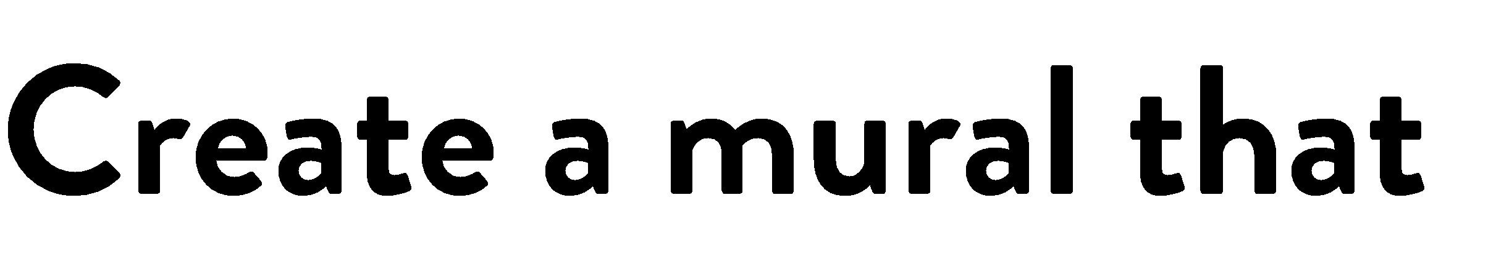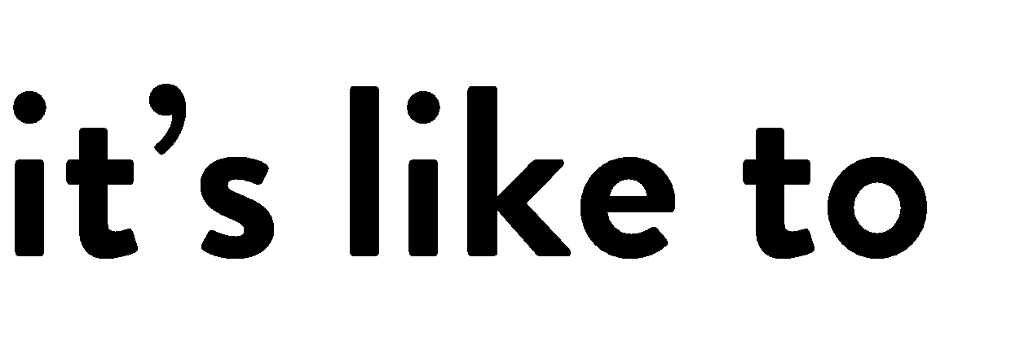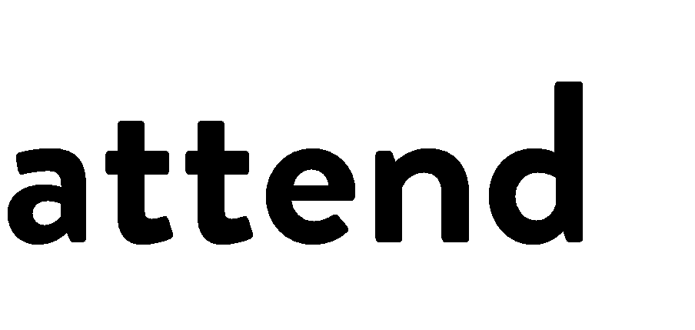

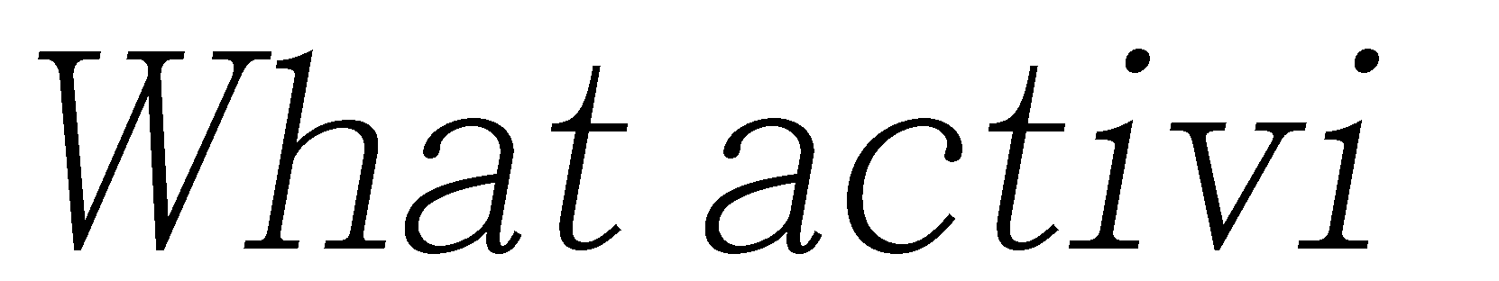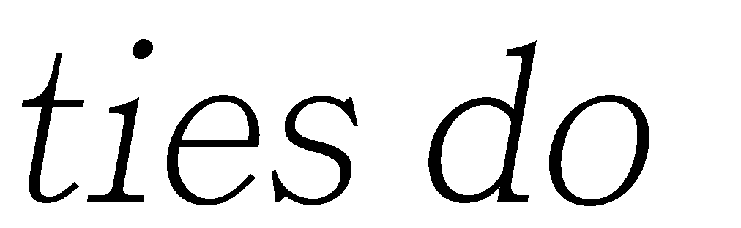

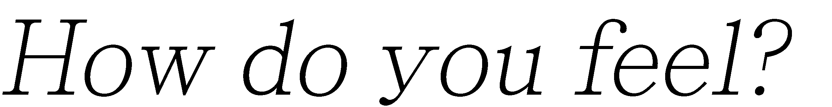

CENSORED!
Mural Rules

Create a mural that shows what it’s like to attend your school.
What activities do you do? Where do you go?

You can only use black, brown or gray to create a calm, orderly picture.

    - Everything you add to the mural must show kids attentive and serious.

    - If the censor doesn’t like anything you are drawing, the censor can black it out.

